App “My Kind Voice” feedback
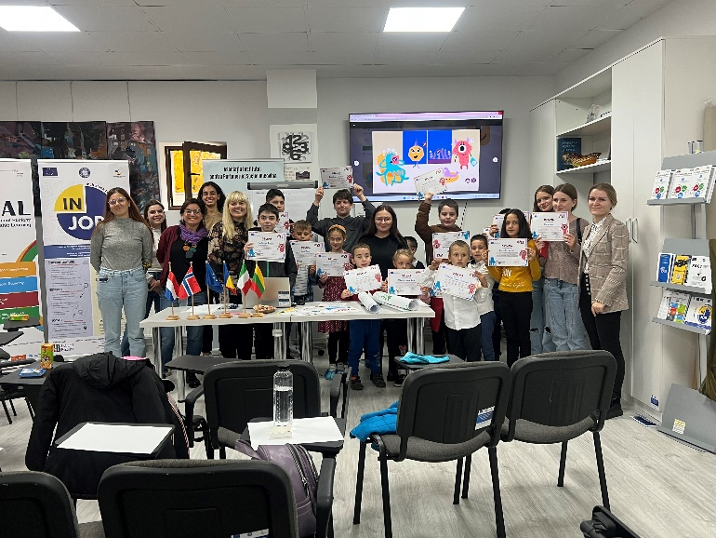
Project VOICE focuses on the challenges of the digital world – cyberbullying and hate speech online. It also proposes a different approach to work - listening to the opinion of children and promoting co-education where schools, as well as parents, are involved in solving these issues. One of the main project results is an app called “My Kind Voice”. It includes 16 games and activities proposals to be carried out in families and at school to stimulate co-education on the issues around the topics of cyberbullying and hate speech. In order for the app to be suitable for the target groups and to help achieve the project's goals, we carried out piloting of the app in various schools in Lithuania, the Netherlands, Romania, Norway and Italy. Partners played with the app and its activities in a lot of schools. We asked children to become the testers of the app and provide their feedback. Here are some of their thoughts.
Children’s feedback
“I liked the game because it teaches you how to behave with other children, how to recognize their emotions, what to say to them to make them feel good.”
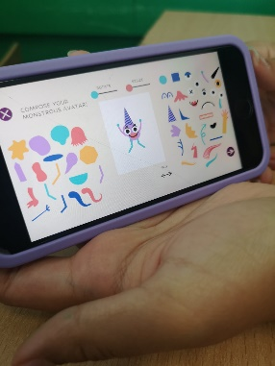
“They brought in our attention My Kind Voice app during the session. I thought it would be something boring, but when I arrived home, I continued playing it. It is a simple and friendly game.”
“I found today’s app very engaging and even funny. From my point of view, it is a little game that helps you learn the good things and how to behave with those around you.”
“I really liked the app, it is very interesting and educational, and I will continue to use it to learn as much new information as possible.”
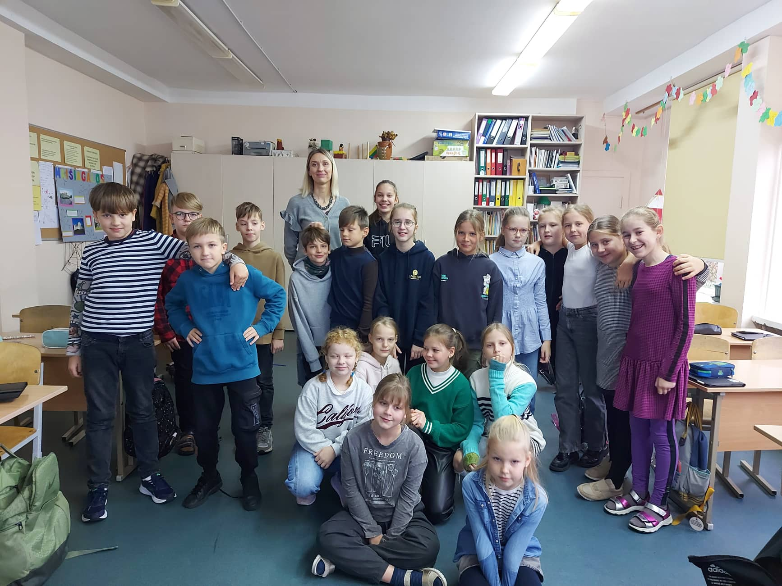
During the piloting of the app, children had a great opportunity to work all together, be friendly to each other and help each other.
The children found the app very interactive, modern and playful. They really loved the freedom of creating their own monster and that the monster has a journey in the app! They said they found it great that they can share and discuss their answers with their friends and classmates. The children also thought it is amazing that they can make and add photos in the app.
Children enjoyed playing with the app and had a lot of fun while learning a lot. They thought that making their own monster was fun, but also made them connect with the app. Children said that they want to continue following the rules to be safe online because they think it is important. They also think that the monster can give a good lesson to other classmates that are not very good every day. During the session in schools children wanted to continue with the “at home” section of the app and were excited to explore it as soon as possible together with their parents.
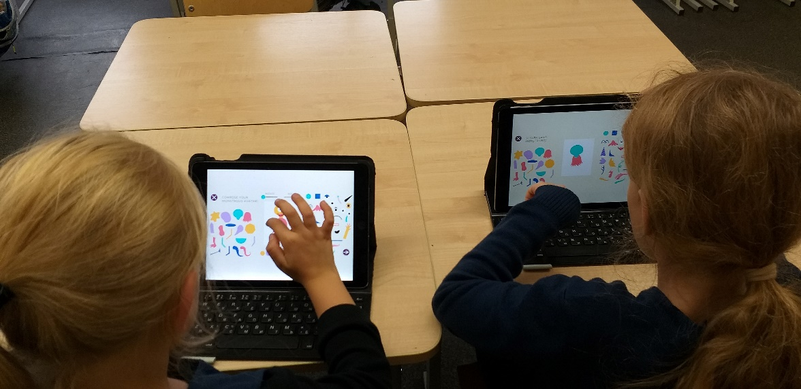
Children liked the compliments that they read and think that they want to say positive things to their friends more often. The children said that they learned a lot about what and who a bully is and how to know when they see one. They also said that this was a very nice activity. They added that they want to tell their parents what they learned today in school.
Teachers’ thoughts
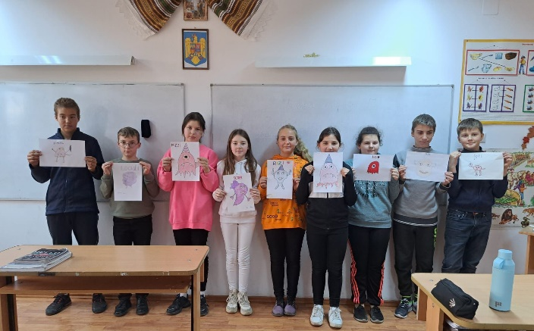
“The children played My Kind Voice app and created Basa, the little monster, and they learned how to behave nicely, and they chose the best solutions for the hard/bad situations they face at home or at school.”
“The children installed the My Kind Voice interactive application and were particularly excited about it ("cool", "cool", "cool"). Such materials are useful for our classes, being much easier for children to understand the phenomenon of cyberbullying in this way.”
“Children tested the app and they liked the most that they could create their own little monsters.”
“Now we all benefit from the My kind voice app, with students saying that spending time there is very enjoyable. They were delighted to meet with the two spaces SCHOOL and HOME and in the online environment. They seemed very interested in an educational game that adults would allow them to play!”

Parents’ thoughts
“She absolutely loved the monsters and the idea of ​​the game; She did great with all the activities the only drawback was that she can't read, and I had to read to her. But she made the decisions and actions herself.”
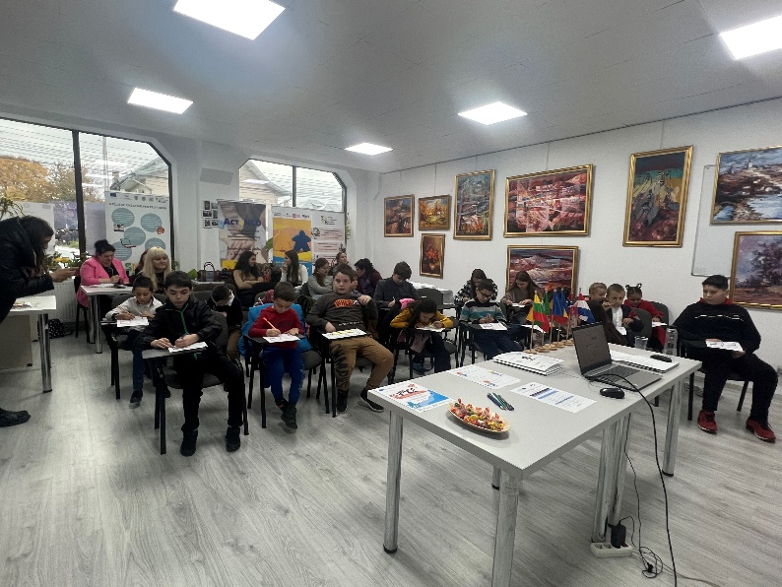
“I tested the My Kind Voice application from Google Play. The response after using it was: “Dad, I am NOT allowed to give other people personal data! Interesting app.” If a 9-year-old can say this, then I think the goal has been achieved!”
Overall, we are glad that we managed to involve such a large number of children, parents, and teachers. The feedback on the app was very useful and important for us because it helped to see the advantages and disadvantages of the app. We are grateful that most of the participants gave very positive opinions about the app and learned something from it. It shows that we did a great job!
If you want to try the “My Kind Voice” app visit the project’s website: https://www.erasmusvoice.eu/
Some moments from piloting:
